Please advise Timekeeper if you will have a delegate over the Payroll Deadline. This will ensure notifications go to the appropriate party. Timekeepers have no way of knowing if a delegate has been assigned and will send notifications to the default party unless otherwise specified.
Select Control + Link for hyperlinks

Delegation Request | Information Sheet
Overview of Delegation
The PeopleSoft Delegation functionality enables one person to authorize another to serve as his or her representative when working with transactions in Absence Management and Time and Labor.
For example, a manager can delegate timekeeping responsibilities to another person due to workload or their own absence from the office. An employee can delegate the entering of his or her time and absence to another person while away from the office. In both examples, the absence administrator for the UTA Talent, Culture & Engagement team will assist in processing.
Please note that upon delegating to an approved proxy, you as the delegator will lose access to perform the delegated functions until the proxy’s delegation is withdrawn.
The delegation may only be assigned once (the proxy cannot assign to another proxy).
Actions available for Delegation
- Entering, approving, or denying absence requests
- Approving or entering employee timesheets

Authorized Recipients to receive Delegated Authority
- Downward delegation – A direct report who will act as proxy
- Upward delegation – A manager (or higher) of the Delegator making the request
- Lateral delegation – A peer who will serve as timekeeper

Tasks the Absence Administrator Completes
- Establishing the delegation on behalf of the supervisor/requestor
- Extending the end date for the delegation as advised
- Revoke the delegation (typically if it needs to stop prior to the existing end date)
- Communication with the Supervisor/Timekeeper if additional information is needed
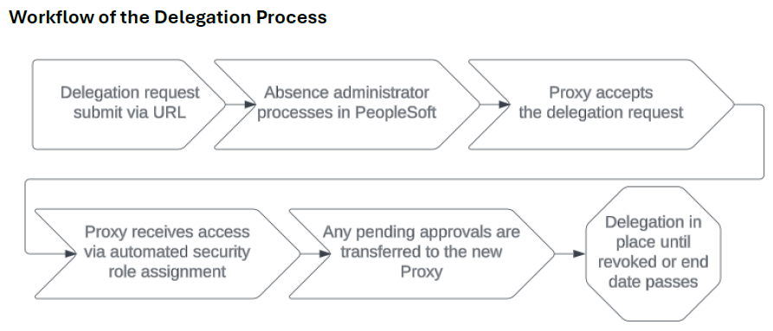
URL for submitting delegation requests
Delegation Request Form Link
Information needed to complete the form
- Supervisor Employee ID
- Supervisor Name
- Proxy Employee ID
- Proxy Name
- Delegation Start & End Dates

What happens next?
- You should receive an approval request from PeopleSoft (3-5 business days)
- Once fully approved, your access will auto-assign and delegation will be live

Questions?HRMS@uta.edu

